**Unit 2**

**Q2: Good Number**

Algorithm:

Step 1: Start the program

Step 2: Take input from user and store in variable n

Step 3: Check if n is zero, if not then run a loop to separate its digit by dividing it through 10.

Step 4: If remainder of n/10 is 0 then its not a Good number, break that loop.

Step 5: If the loop reaches its termination condition then it’s a Good Number.

Step 6: Stop

Flowchart:

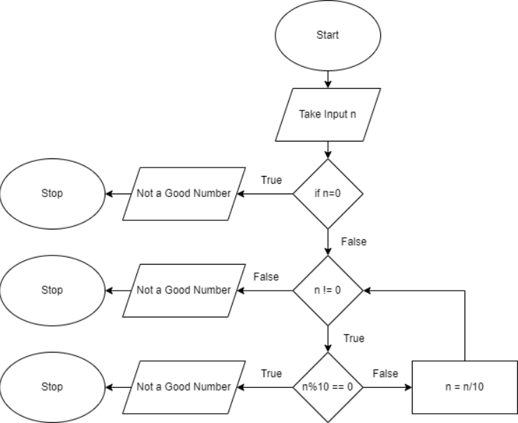

Code:

#include <stdio.h>

#include <string.h>

int main()

{

    int n;

    printf("Enter the number: ");

    scanf("%d",&n);

    if(n){

        for(;n!=0;n/=10){

            if(!(n%10)){

                printf("Not a GOOD Number");

                break;

            }

        }

        if(!n) printf("GOOD Number");

    }

    else printf("Not a GOOD Number");

    return 0;

}

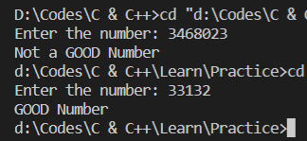Sample Input and Output:

**UNIT-3**

**Q3: John and Peter word game**

Algorithm:

Step 1: Start the program

**Step 2: Assign variable i to 1 and char c to ‘a’**

Step 3: Run a loop based on the condition if i is not zero.

Step 4: Take input from John and Peter turn wise by checking odd and even value of i.

Step 5: If first character of the input word matches with c then assign c the last character of the input word and increment i.

Step 6: If it doesn’t match then the word entered was wrong. Assign i to 0 to falsify the loop condition, to terminate it.

Step 7: Stop

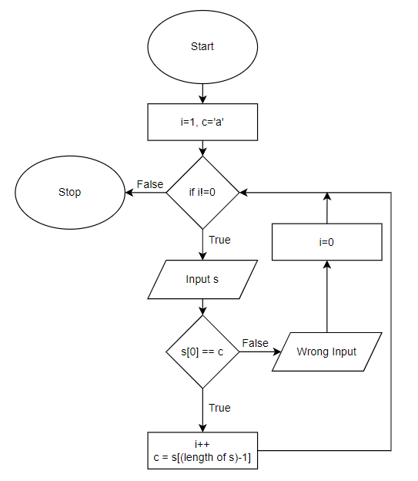Flowchart:

Code:

#include <stdio.h>

#include <string.h>

int main(){

    char c='a',s[100];

    int i=1;

    while(i){

        printf("%s's turn: ",(i%2)? "John" : "Peter");

        scanf("%s",s);

        if(s[0]==c){

            c=s[strlen(s)-1];

            i++;

        }

        else{

            printf("Wrong word, %s lost",(i%2)? "John" : "Peter");

            i=0;

        }

    }

    return 0;

}

Sample Input and Output:

